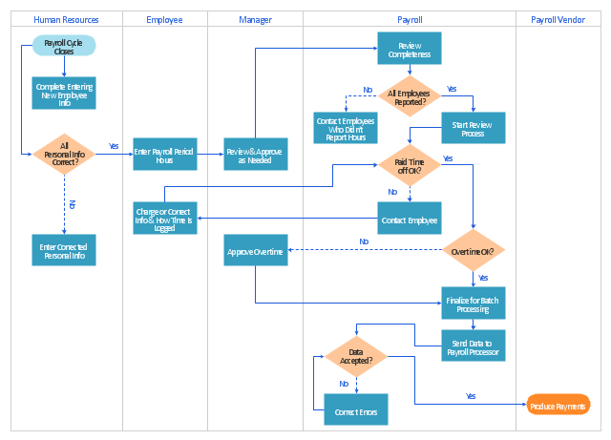Simple_SME_Payroll Swimlane Diagram